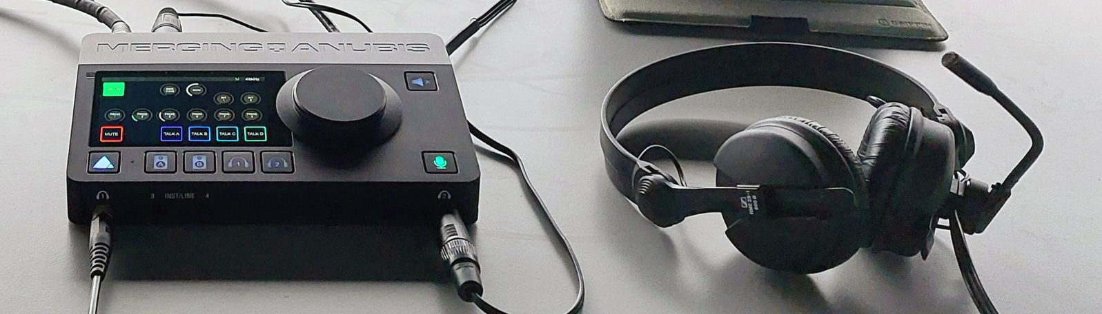Interpretation solution with Anubis and Hapi from Merging Technologies
A cost-effective interpretation solution from the digital audio experts

Puidoux/Amsterdam, 15 September 2023 – Interpretation at conferences, business meetings and broadcast events is more in demand than ever but often associated with complex set-ups and cost. Now, Merging Technologies has joined forces with Sennheiser’s business communication experts to create a very flexible and cost-effective interpretation solution based on their Anubis interface. Connect Sennheiser headsets (mic/headphone combos) and your interpretation desk is ready! A Merging Technologies Hapi Mk II serves as the connection point to the console, PA or conferencing system.

The Anubis audio interface can handle two high-end microphone inputs with EQ, compressor and limiter and two headphone outputs with a touch screen, a rotary dial for the headphone volume and a hard button for direct mute control by the interpreters. The inputs and outputs are totally separate so that each interpreter can choose their volume level etc. completely independently from their colleague.

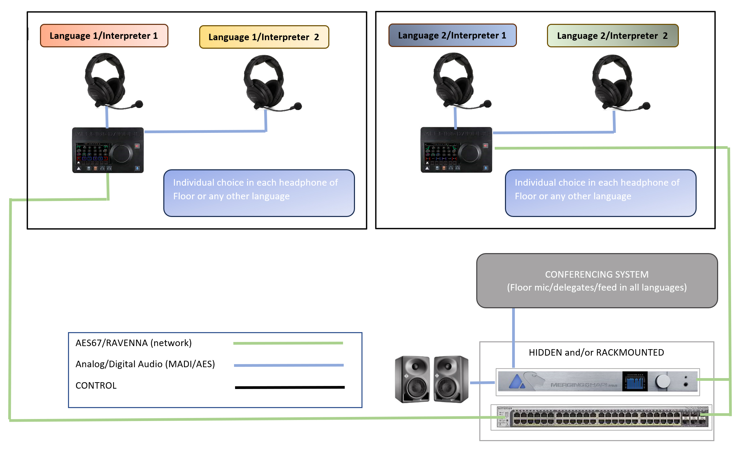 | Diagram of the Merging Technologies’ interpretation solution

All Anubis are network-interconnected (AES67/ST2110) so that every audio stream can be made available on any Anubis. A Hapi Mk II (AD/DA, Madi, AES/EBU converter) is used as an in/out point with all standard formats to connect to the existing console, PA or conferencing system. One key benefit of this interpretation solution is that it can be remote-controlled via VPN and the IP address of each Anubis.

“Interpreters will have an intuitive solution for their work, while set-up and control are as easy, flexible and versatile as possible for the event techs,” says Maurice Engler, senior product & project manager.

If you want to learn more about this interpretation solution, visit the Sennheiser Group stand in Hall 8, D50. Presentations of Anubis and the possibilities it offers take place every day at 14:00.

(Ends)

The images accompanying this media release can be downloaded here.

About the Sennheiser Group
Building the future of audio and creating unique sound experiences for our customers - this is the aspiration that unites the employees of the Sennheiser Group worldwide. The independent family-owned company Sennheiser was founded in 1945. Today, it is managed in the third generation by Dr. Andreas Sennheiser and Daniel Sennheiser, and is one of the leading manufacturers in the field of professional audio technology.

sennheiser.com | neumann.com | dear-reality.com | merging.com

Merging Technologies Press Contact
Rune Jacobsen
rune.jacobsen@merging.com

